Water Token

Interest: Medium-low

Challenges: Content Size, Pixel Art

# Section I - Game Overview

## Game Concept

A parody game of the series Fire Emblem. A Top Down strategy game where you command 5 units to face off against an AI enemy. Strategize your approach through various battle elements like weapon advantages, and positioning.

Example:

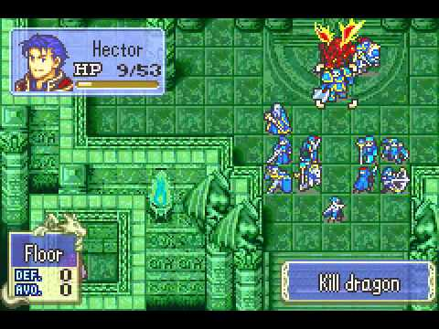

## Design History

## Feature Set

* 20 selectable team mates with varying weapons and stats.
* Multiple maps filled with enemies
* Smart and strategic enemy AI

## Genre

Strategy RPG

## Target Audience

Hardcore gamer

## Game Flow Summary

The game will have a team builder menu, a map selection menu. After these are selected, they are taken to the map, which will display the entire battlefield.

## Look and Feel

The game will have a pixel art style and will feel like a retro strategy game.